Diet and Lifestyle during Pregnancy
Pregnancy is an exciting time. It’s also a time when parents can brush up on important diet and lifestyle information that could have an impact on the health of your pregnancy.
Diet
The definition of a healthy diet does not change with pregnancy. A weight gain of 10-14kG over the pregnancy is associated with the lowest risk of pregnancy complications. Eating for two doesn’t mean eating double. You need roughly 300-400kCal more per day when pregnant. There are certain foods however, that can have damaging effects.
Fish: in general, fish is a good source of protein and other nutrients. Aim to eat at least two portions of fish per week, with at least one portion being oily fish, including mackerel, sardines, salmon, trout and fresh tuna. However, there are some important exceptions. Some types of fish contain a high level of mercury, which can damage the developing nervous system of an unborn baby. You should not eat any shark, marlin, or swordfish. Limit tuna - eat no more than four medium-sized cans (drained weight = 140 g per can) or two fresh tuna steaks per week (weighing about 140 g cooked or 170 g raw). Also, do not eat raw fish or uncooked shellfish (which may contain germs (bacteria), viruses or parasites).
Also, some types of fish may contain a small amount of chemicals from pollution, including dioxins and polychlorinated biphenyls (PCBs). If you eat a lot of these fish, these chemicals may build up in your body over time, which may be harmful. These fish are sea bream, sea bass, turbot, halibut, rock salmon (also known as dogfish, flake, huss, rig or rock eel) and brown crabmeat. Canned fish in general are not recommended as canned foods as well as heated plastics leech chemicals into your food.
Foods and drinks to avoid
You should not eat the following if you are pregnant:
Anything with a lot of vitamin A. You need a small amount of vitamin A to keep healthy. However, large amounts can harm an unborn baby. So, avoid:
Liver and liver products such as liver pâté and cod liver oil supplements. Vitamin tablets or supplements which contain vitamin A.
Food, which may have high levels of listeria including:
Undercooked meats and eggs. This may occur in some pre-cooked meats and pre- prepared meals. Make sure all meat foods are cooked until piping hot. Eggs should be cooked until the white and yolk are solid. Avoid foods that may contain raw eggs, such as some types of mayonnaise and mousse.
Mould-ripened and soft cheeses such as brie, Camembert and blue-veined cheeses. (Hard cheeses and processed cottage cheese are safe.) Pâtés - including vegetable pâtés, raw shellfish and raw fish.
Safe cheeses in pregnancy
- Hard cheeses: smoked versions, cheddar, edam, emmental, English goat's cheddar, feta, gouda, gruyere, halloumi, havarti, jarlsberg, manchego, orkney, paneer, parmesan, pecorino (hard), provolone.
- Soft, processed cheeses: garlic and herb roulade, cottage cheese, cream cheese, feta, goat's cheese without a white rind, mascarpone, mozzarella, processed cheese (such as cheese spread and cheese segments), quark, ricotta.
- Yogurts, probiotic drinks, cream cheese, soured cream and creme fraiche are all safe to eat. These include any variety, including natural, flavoured and live versions.

Potentially unsafe cheeses in pregnancy
- Mould-ripened soft cheeses: brie, blue brie, cambozola, camembert, chevre (goat's cheese with a white rind), pont l'eveque, taleggio, vacherin-fribourgeois.
- Blue-veined cheeses: bergader, bleu d'auvergne, blue wensleydale, shropshire blue, danish blue, dolcelatte, gorgonzola, roncal, roquefort, stilton, tomme.
- Soft, unpasteurized cheese, including goat's and sheep's cheeses: chabichou, pyramide, torta del cesar.

Unpasteurised milk. Note: goat's milk is often unpasteurised, and goat's milk products such as cheeses are often made from unpasteurised milk.
Limit the amount of caffeine to no more than 200 mg per day. Caffeine is a substance that occurs naturally in foods such as tea, coffee and chocolate; is added to some drinks such as cola, and some energy drinks; and is an ingredient of some cough and cold remedies, and some painkillers which you can buy at pharmacies. Having a lot of caffeine increases your risk of having a miscarriage and a baby with low birth weight. The increased risk is small. But, it is best to play safe. The main sources of caffeine are coffee, tea, chocolate, and cola. It is also added to some energy drinks and to some cough and cold remedies. As a rough guide:
One mug of instant coffee has about 100 mg of caffeine. One mug of brewed coffee has about 140 mg of caffeine. One mug of tea has about 75 mg of caffeine. One 50 g plain chocolate bar has about 50 mg of caffeine. Milk chocolate has about half the caffeine that plain chocolate has.
One can of cola or half a can of an energy drink has up to 40 mg of caffeine. See chart below:
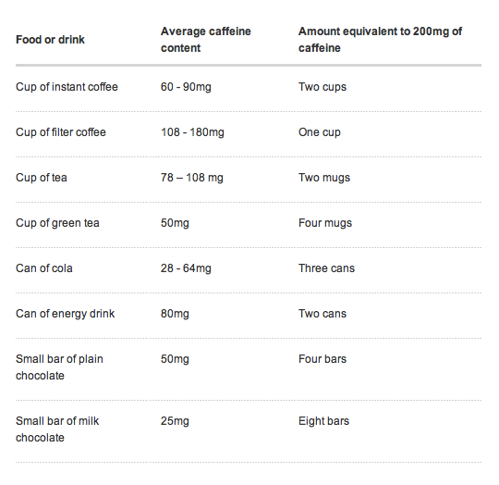
Vitamins and supplements
Folic Acid: you should take folic acid tablets (supplements). Ideally, do this from at least one month before you get pregnant, and continue taking them until at least the end of the 12th week of pregnancy - even if you are healthy and have a good diet. Folic acid is a naturally occurring vitamin found in spinach, sprouts, broccoli, green beans, and potatoes. Some bread and breakfast cereals are fortified with folic acid. However, you need a good supply of folic acid when you are pregnant to help with the development of the baby. If you take folic acid tablets in early pregnancy you reduce the risk of having a baby born with a spinal cord problem such as spina bifida. There is evidence that folic acid also reduces the risk of having a baby born with a cleft lip and palate, a heart defect (congenital heart disease), and the risk of a premature (preterm, 'prem' or early) labour.
For most women, the dose is 400 micrograms (0.4 mg) a day. If you have an increased risk of having a child with a spinal cord problem then the dose is 5 mg a day.
Vitamin D supplements: vitamin D is needed for growth and supplements are recommended for all pregnant women, breast-feeding women and breast-fed babies. The dose if you are pregnant or breast-feeding is 400 units (10 micrograms) daily. Some experts think that women who get little or no sunshine on their skin need a higher dose, such as 800 units (20 micrograms) daily. This is because most of the vitamin D that we get is made in the skin with the help of sunlight.
Lifestyle
Alcohol
Women who are pregnant should not drink alcohol. The reason for this is that alcohol can cause damage to a developing baby. Alcohol gets to a baby through the placenta if a pregnant woman drinks alcohol. A baby cannot process alcohol very well. So, any alcohol in your baby stays in their body much longer than in you. This is known to be a risk for causing serious problems. For example, studies have shown that:
Pregnant women who drink more than 15 units a week have an increased risk of having a baby with a low birth weight. Pregnant women who drink more than 20 units a week have an increased risk of having a baby with some damage to the brain, causing impaired intellect.
Pregnant women who drink very heavily risk having a baby with fetal alcohol syndrome. Babies with this syndrome have brain damage, a low birth weight and facial malformations.
However, there has been debate over the years as to whether small amounts of alcohol are safe to drink during pregnancy. Also, if there is a time of pregnancy when alcohol is most likely to cause harm. But, recent research supports the advice of not drinking any alcohol whilst pregnant. More recent evidence suggests that ANY alcohol is harm inducing including cognitive effects to the baby.
Teas and Herbs:
Red Raspberry, Peppermint, Lemon Balm and Ginger are considered the safest teas to drink during pregnancy but even then keep them in moderation (no more than one cup per day). Peppermint can cause reflux and while ginger is great for morning sickness it should be kept in moderation for when you are not nauseous.
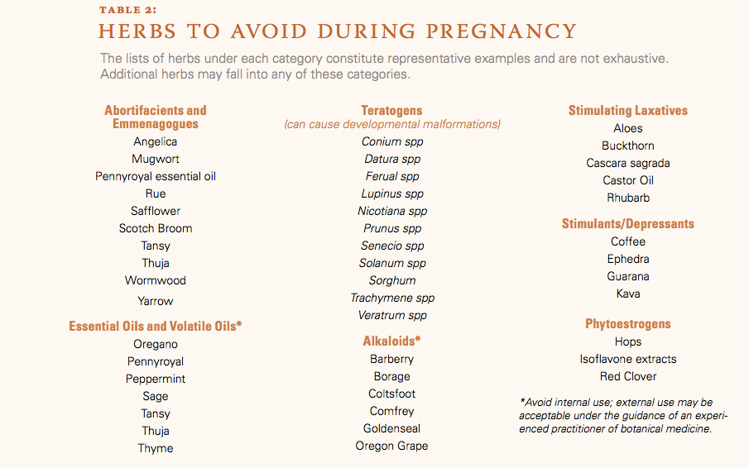
Exercise
For most women, it is important to do some regular physical activity during pregnancy as part of living a healthy lifestyle. In most cases, moderate physical activity during pregnancy is safe and can have benefits for both you and your baby and should not harm either of you. However, you do need to be sensible about what type of physical activity you do. You should aim to do a mixture of both aerobic physical activity and muscle- strengthening physical activity. In general, at least 30 minutes of physical activity every day is recommended. Physical activity during pregnancy is safe for most women.
Sex
Sex is safe for most couples during pregnancy. The penis will go no further than your vagina and the baby will be unaffected. Later in pregnancy, sex and orgasm may provoke contractions known as Braxton-Hicks contractions. These make your bump feel hard. They can be uncomfortable but are quite normal. They usually pass after a few minutes.
Working during pregnancy
If you think that your job may pose a risk to a pregnancy, then ideally you should discuss this with your employer before you become pregnant or as soon as you become pregnant.
If you work with certain animals for example: You should avoid contact with sheep and lambs at lambing time. This is because some lambs are born contaminated with germs such as listeria, toxoplasma and chlamydia which may affect you and your unborn baby. Cats and kittens often carry toxoplasma germs. Especially, cat poo (faeces). So, cleaning out cat litters and handling cats and kittens can be a risk.
If your job puts you at risk of contracting hepatitis B, you should be immunized against this virus. For example, if you are a healthcare worker, or work at a daycare or residential center. (Women with hepatitis B can pass on the infection to their child at childbirth.) If you work with chemicals, fumes, radiation, etc. Some may be toxic to an unborn baby.
When you have any questions please do not hesitate to ask Dr. Parmar. Have a happy and healthy pregnancy!
In health,

Dr. Bobby Parmar Physician at evolve Vitality

